**BEGINNING OF TERM ONE EXAMINATIONS 2024**

**Reading 4-5 years**

Name _________________________Stream ___________

1. **Sound and do the action.**

a t c f m d

2. **Blend and read syllables.**



s – a = s a

t – a = t a

m – a = m a

p – a = p a

3. **Circle the given sound**

t p t

s s a

g h g

i i c

[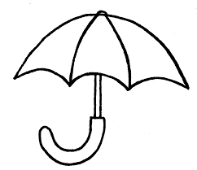](http://www.google.com/imgres?imgurl=http://images.clipartpanda.com/cute-umbrella-drawing-umbrella-thoughtsoftraveling.png%26imgrefurl=http://www.clipartpanda.com/categories/cute-umbrella-drawing%26h=688%26w=796%26tbnid=X2DneVpKlT52bM:%26zoom=1%26docid=NGc3lf-tlHZpKM%26hl=en%26ei=lvoTVYy_BYj7UIjmgIgF%26tbm=isch%26ved=0CA4QMygGMAY4ZA)4. **Match pictures of the same sounds.**

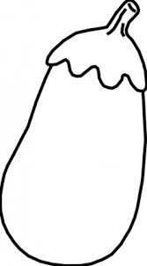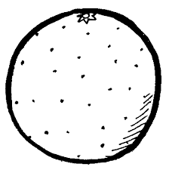

[](http://www.google.com/imgres?imgurl=http://images.clipartpanda.com/cute-umbrella-drawing-umbrella-thoughtsoftraveling.png%26imgrefurl=http://www.clipartpanda.com/categories/cute-umbrella-drawing%26h=688%26w=796%26tbnid=X2DneVpKlT52bM:%26zoom=1%26docid=NGc3lf-tlHZpKM%26hl=en%26ei=lvoTVYy_BYj7UIjmgIgF%26tbm=isch%26ved=0CA4QMygGMAY4ZA)





5. **Match and copy.**

s n ___n_____

a i __________

t c __________

c s __________

i a __________

n t __________